WEEK 1: SECURITY ASSESSMENT REPORT
DevelopersHub Corporation Cybersecurity Internship

Intern Name: | Ayesha
GitHub: | aisha-cybersec
Date: | 17 May 2026
Application: | OWASP Juice Shop v14.5.1
URL: | http://localhost:3000
Tools Used: | OWASP ZAP 2.17.0, Browser Developer Tools

1. Introduction
This report documents the security assessment performed on OWASP Juice Shop as part of Week 1 of the DevelopersHub Corporation Cybersecurity Internship. The goal was to identify common web vulnerabilities using manual testing and automated scanning tools.

1.1 Application Setup
OWASP Juice Shop was cloned from GitHub and run locally using Node.js v18.20.8 at http://localhost:3000. The following pages were explored:
- Registration page for creating test accounts
- Login page for authentication testing
- Product pages for XSS and injection testing
- Basket/Profile pages for access control testing

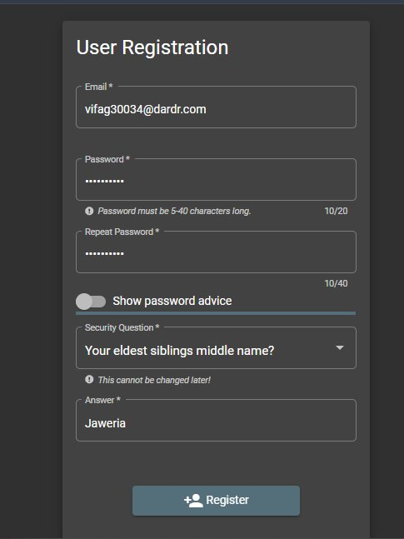
Figure 1: User Registration Page
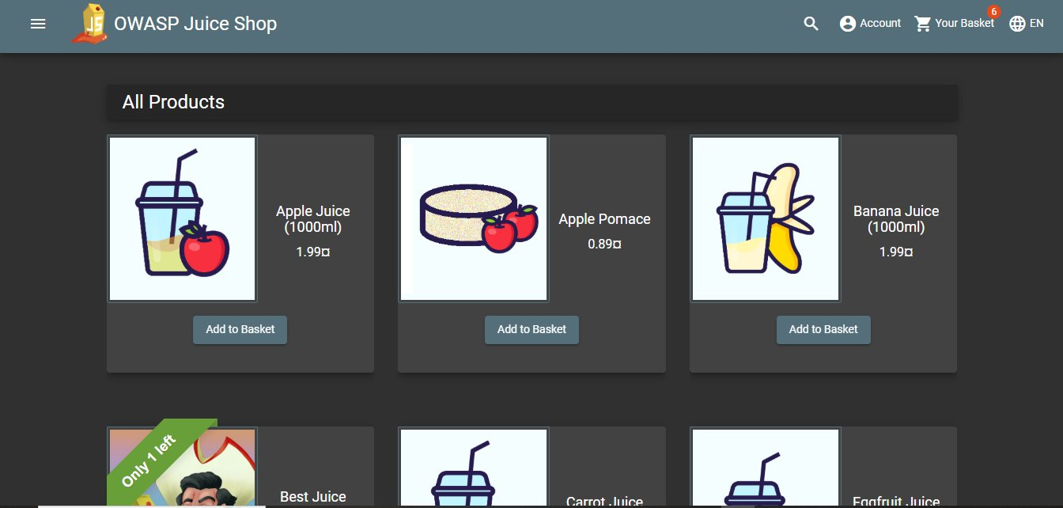
Figure 2: Login Page

2. Vulnerability Assessment

2.1 Testing Methodology
- Manual testing using Browser Developer Tools (F12)
- SQL Injection testing on login form using exact task payload
- XSS testing using script tag and iframe payloads in search field
- Automated vulnerability scanning using OWASP ZAP 2.17.0

2.2 Vulnerabilities Found

Vulnerability #1: SQL Injection

Vulnerability #1: SQL Injection
Location | Login Page to Email Field
Severity | CRITICAL
Payload Used | ' OR 1=1-- and admin' OR '1'='1 (Task specified payload)
Result | Successfully logged in as admin@juice-sh.op without password. Admin access fully gained.

SQL Injection occurs when user input is inserted into SQL queries without sanitization, allowing attackers to manipulate database logic.

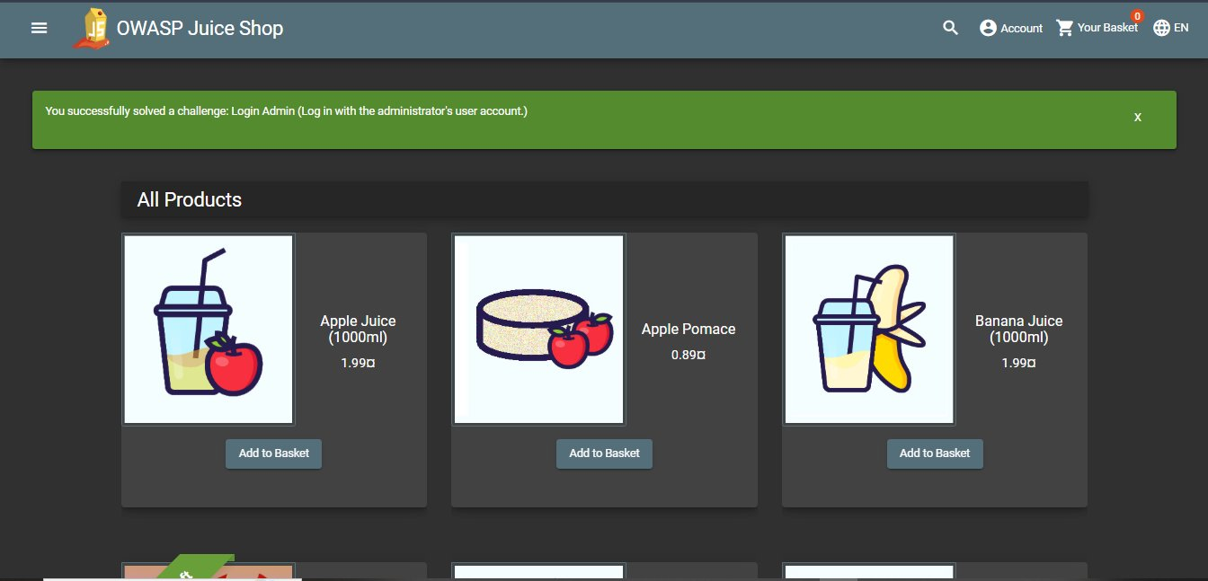
Figure 3: SQL Injection Successfully logged in as Admin (Login Admin challenge solved)
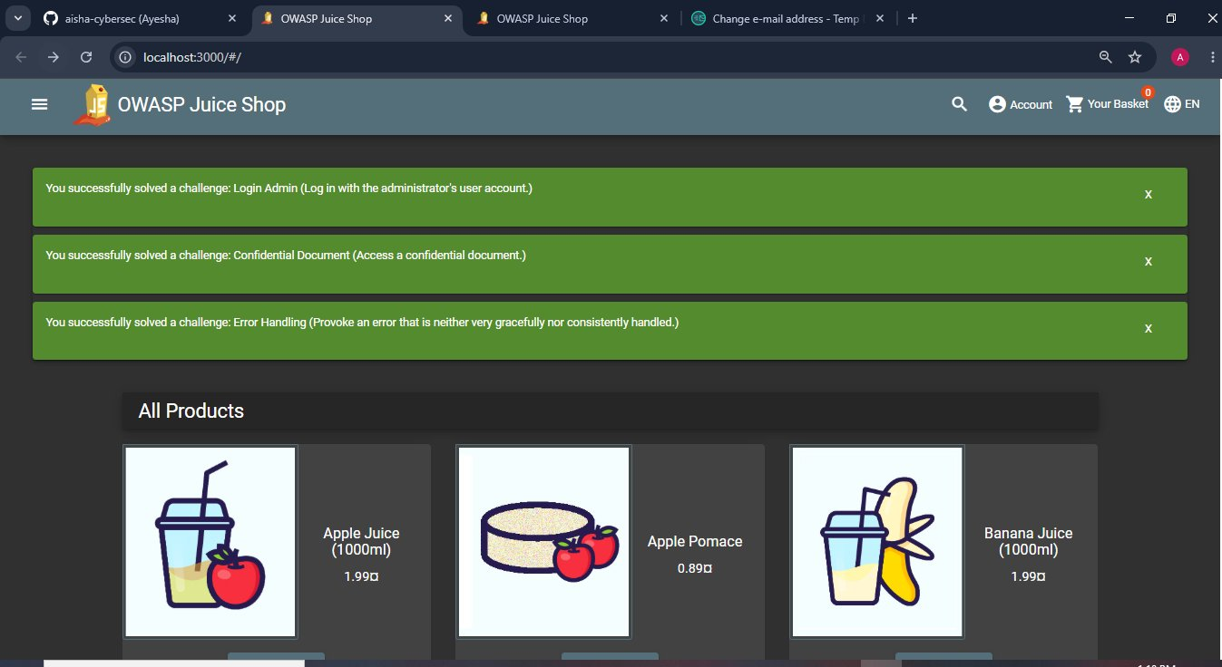
Figure 4: SQL Injection Proof 3 challenges solved including Login Admin, Confidential Document & Error Handling
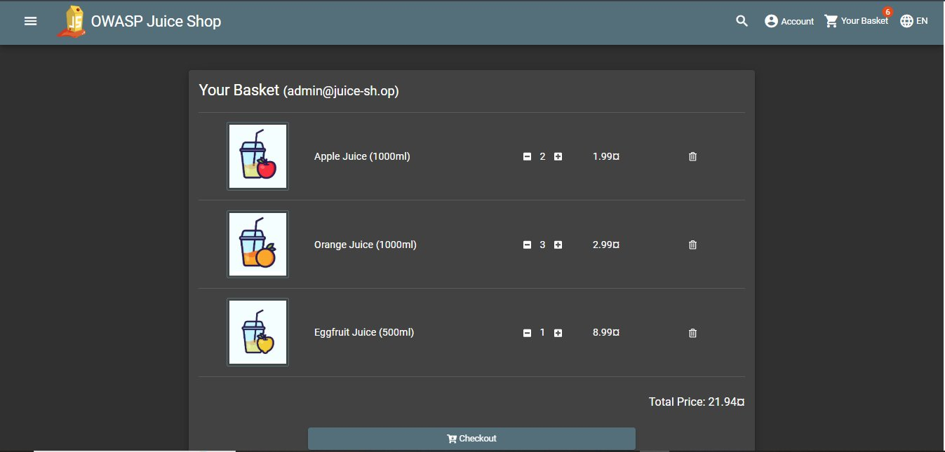
Figure 5: Admin basket accessed showing admin@juice-shop account confirming full admin access

Vulnerability #2: Cross-Site Scripting (XSS)

Vulnerability #2: Cross-Site Scripting (XSS)
Location | Search Bar as Search Input Field
Severity | HIGH
Payload Used | <script>alert('XSS');</script> and <iframe src="javascript:alert('XSS')">
Result | Script tag injected into URL and iframe rendered on page — XSS vulnerability confirmed.

XSS allows attackers to inject malicious scripts into web pages. This can steal session cookies, redirect users, or perform unauthorized actions.

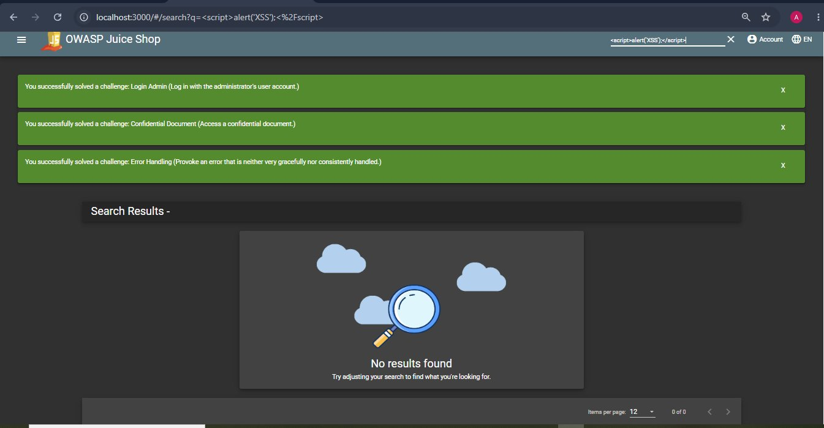
Figure 6: XSS Test <script>alert('XSS');</script> injected into search bar (Task specified payload)
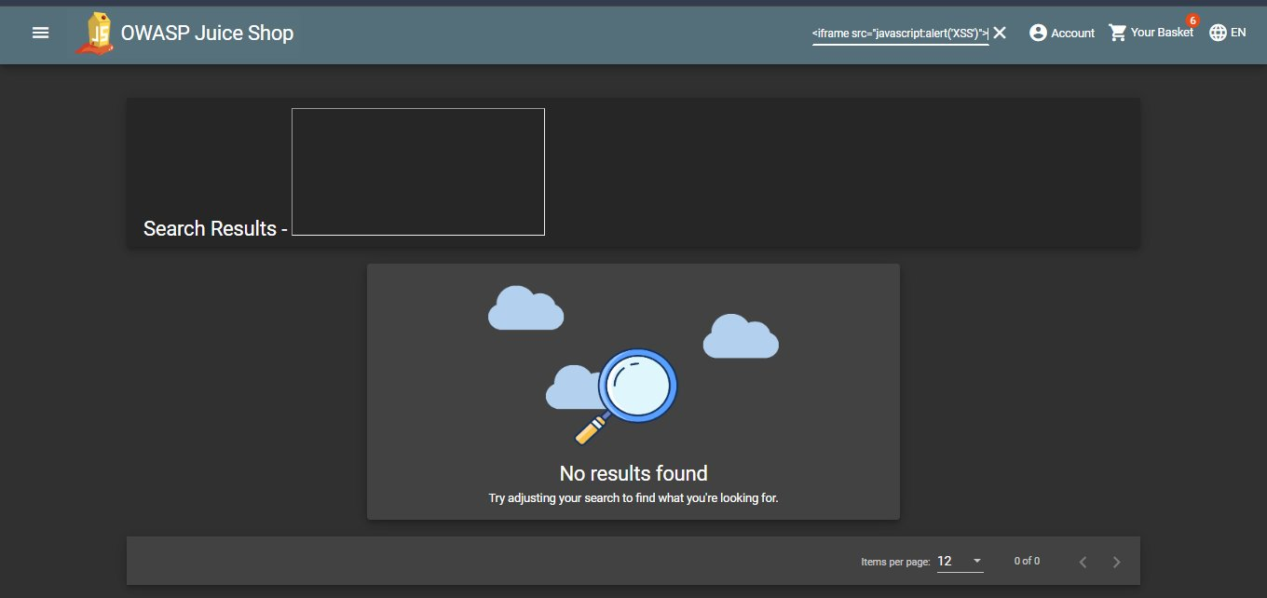
Figure 7: XSS Test iframe payload rendered on page confirming XSS vulnerability

Browser Developer Tools Testing
Browser Developer Tools (F12) were used to inspect application behavior, monitor network requests, and analyze security issues:
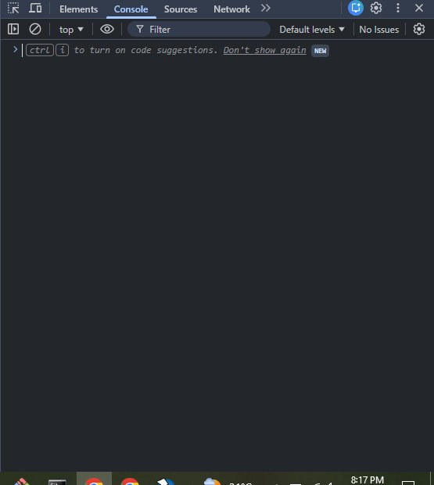
Figure 8: Browser Developer Tools Console Tab showing application logs
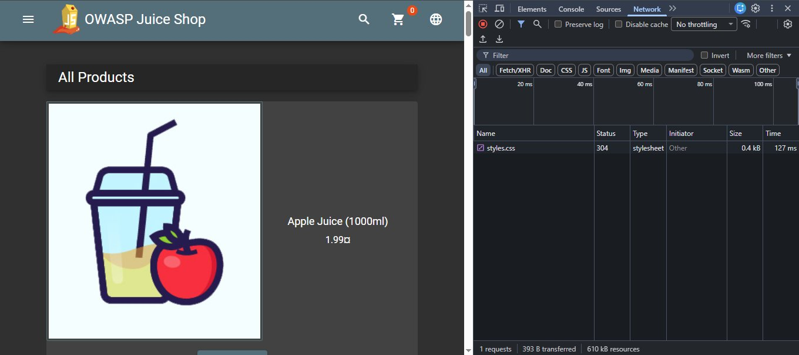
Figure 9: Browser Developer Tools Network Tab showing HTTP requests and responses
Vulnerability #3: Weak Password Policy

Vulnerability #3: Weak Password Policy
Location | User Registration Page
Severity | HIGH
Payload Used | Registered with simple numeric password
Result | Application accepts very weak passwords — no complexity requirements enforced.

Vulnerability #4: Security Misconfigurations (OWASP ZAP)
OWASP ZAP automated scan found 7 additional vulnerabilities:
# | Vulnerability | Risk Level | Description
1 | Content Security Policy Not Set | Medium | Allows XSS and injection attacks
2 | Cross-Domain Misconfiguration | Medium | Overly permissive CORS policy
3 | Cross-Domain JS Source File Inclusion | Low | External JS without integrity checks
4 | Timestamp Disclosure - Unix | Low | Server leaks system timestamps
5 | Information Disclosure - Comments | Info | Source code reveals implementation details
6 | Modern Web Application | Info | Framework requires additional security
7 | User Agent Fuzzer | Info | Inconsistent responses for different agents

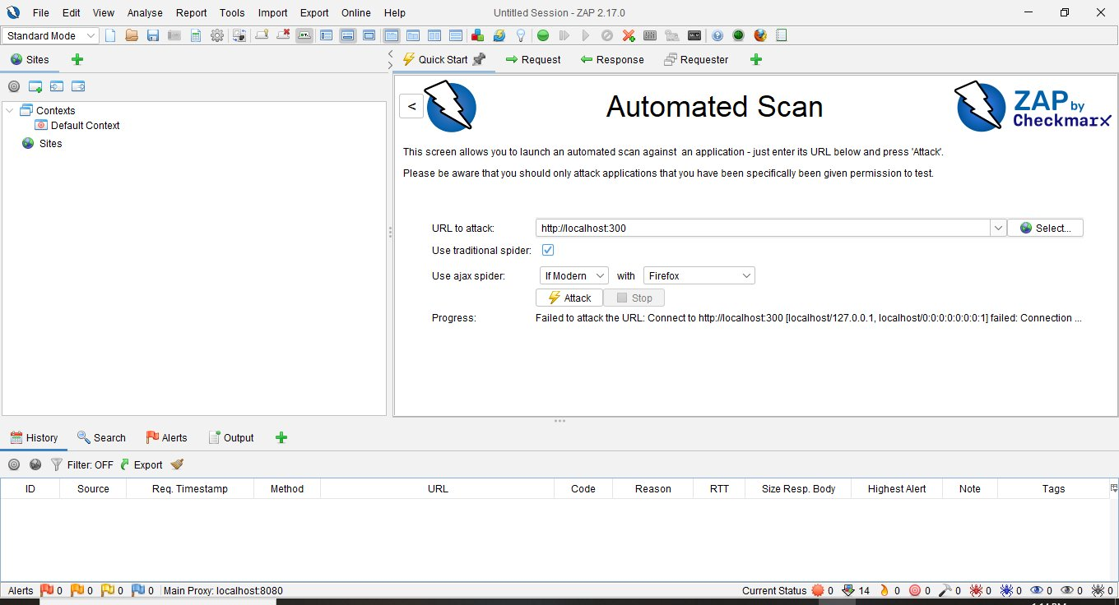
Figure 10: OWASP ZAP Automated scan running at http://localhost:3000

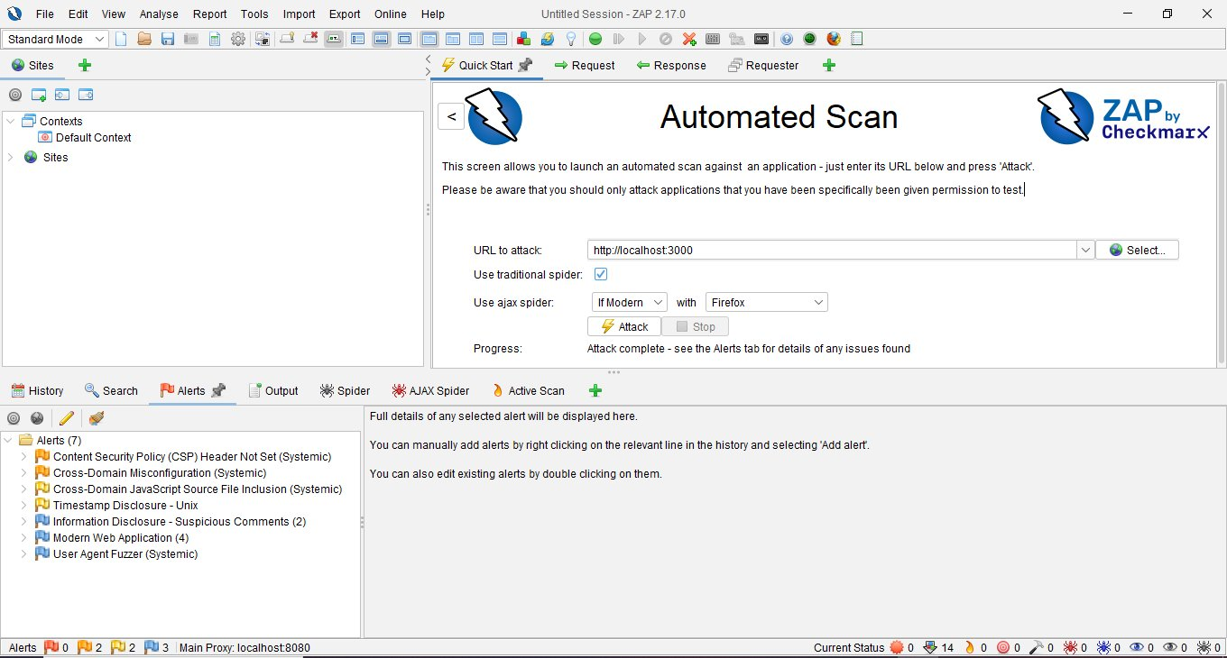
Figure 11: OWASP ZAP Scan complete showing 7 alerts found

3. Areas of Improvement

3.1 Fix SQL Injection
- Use parameterized queries / prepared statements in all database operations
- Implement strict input validation on all form fields
- Use an ORM to handle database queries safely

3.2 Fix Cross-Site Scripting (XSS)
- Sanitize and encode all user inputs before rendering
- Implement Content Security Policy (CSP) headers
- Use DOM Purify library to sanitize HTML content

3.3 Fix Weak Password Policy
- Enforce minimum 8 character password length
- Require uppercase, lowercase, numbers and special characters
- Implement account lockout after failed login attempts

3.4 Fix Security Misconfigurations
- Add Content Security Policy headers to all responses
- Configure CORS to only allow trusted domains
- Remove sensitive information from source code comments
- Implement HTTPS for all data transmission
- Use Helmet.js to set secure HTTP headers automatically

4. Summary
# | Vulnerability | Severity | Status
1 | SQL Injection | CRITICAL | Found -- Fix in Week 2
2 | Cross-Site Scripting (XSS) | HIGH | Found -- Fix in Week 2
3 | Weak Password Policy | HIGH | Found -- Fix in Week 2
4 | CSP Header Not Set | MEDIUM | Found -- Fix in Week 2
5 | Cross-Domain Misconfiguration | MEDIUM | Found -- Fix in Week 2
6 | Timestamp Disclosure | LOW | Found -- Monitor
7 | Information Disclosure | LOW | Found -- Monitor

Week 1 Assessment Complete

